**In-Class Task 1 - Part 1 Instructions: Test an application and find an error**

In this In-Class Task, you’ll run a version of the Email List application and discover that it stops running due to a coding error. Then, you’ll use Chrome to identify the statement that caused the error. Estimated time: 5 to 10 minutes.

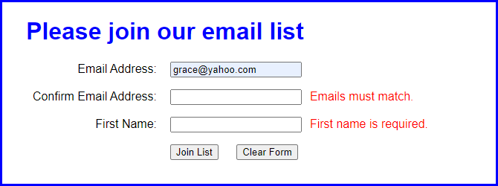

1. Open the application in this file:

Evaluations\In-Class Tasks\In-Class Task 1\email_list.zip

1. Start the application, enter an email address in the first text box, and click the Join List button. Note the error messages that are displayed to the right of the other two text boxes.
2. Enter a different email address in the second text box, and enter your name in the third text box. Then, click the Join List button to see what error messages are displayed.
3. Enter valid data in all three text boxes and click the Join List button. Then, note that nothing happens.
4. Use Chrome’s developer tools to locate the statement that caused the error.
5. Use your editor or IDE to fix the error. Then, save your files, and test the application again with valid data. This time, a new page should be displayed when you click the Join List button.